

BINV2120-1

2BIN English as a Foreign Language

BURNY Pauline

Léonard De Vinci University-College – Faculty of Science and Technology

*UNIT 3: Programming languages*

# UNIT 3.1: Programming languages

🧩 Vocabulary: Terminology and Programming languages (Part 1)

|  |  |  |  |  |
| --- | --- | --- | --- | --- |
| Question | 1 | 2 | 3 | 4 |
| Which programming language was created by Guido van Rossum and is known for its readability and simplicity? | Ruby | C++ | Python | Java |
| What programming language is primarily used for web development and is often called "the language of the web"? | PHP | C♯ | JavaScript | Swift |
| Which programming language was developed by Microsoft and is commonly used for Windows desktop applications and game development? | Python | C♯ | Go | Ruby |
| What language is frequently used for data analysis, machine learning, and scientific computing? | Java | Javascript | C++ | Python |
| Which programming language was designed to be a "systems language" and is widely used for operating systems and low-level programming? | Swift | PHP | C++ | Rust |
| What language is popular for mobile app development, especially for iOS devices? | C♯ | Java | Swift | Python |
| Which programming language is often used for game development and is known for its performance and flexibility? | Lua | Perl | PHP | TypeScript |
| What language is frequently used for database management and is known for its stability and scalability? | SQL | Ruby | C++ | Go |
| Which programming language was created by Bjarne Stroustrup as an extension of the C language? | Python | Java | C++ | Swift |
| What language is commonly used for building Android applications? | Python | Kotlin | C♯ | Ruby |
| Which programming language is frequently used for scripting, automation, and web scraping? | Ruby | C++ | JavaScript | Perl |
| What language is commonly used for creating artificial intelligence applications and chatbots? | Python | R | Go | Rust |
| Which programming language was developed by Sun Microsystems and is known for its "write once, run anywhere" capability? | C++ | Java | Swift | TypeScript |
| What language is often used for numerical and scientific computing and is popular among engineers and researchers? | Python | Java | C♯ | Fortran |
| What language is commonly used for blockchain development and smart contracts? | Solidity | Python | C♯ | Kotlin |
| Which programming language is the foundation for many Microsoft Windows applications and is known for its extensive standard library? | Java | Python | C♯ | C++ |
| Which programming language is your favourite one? |  |  |  |  |
| Which programming language don't you like? |  |  |  |  |
| Which programming language is the most interesting for your future career? |  |  |  |  |

Listening: My 6 favorite programming languages (and why?)

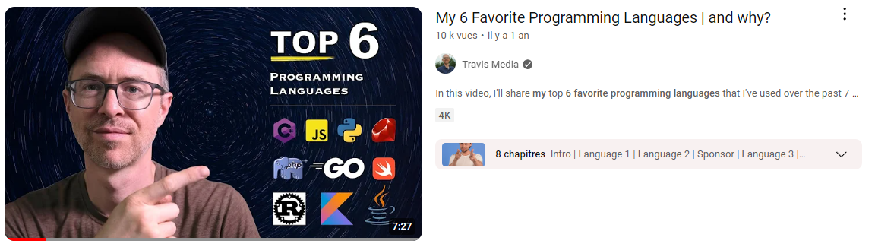

PART 1

* C[dièse](https://commons.wikimedia.org/wiki/File:Llpd%2B1.svg?uselang=fr) is considered multi-paradigm because it can only be functional and procedural.
  + Vrai
  + Faux
* When he was hired as a SRE, the main language they used was C++.
  + Vrai
  + Faux
* C[dièse](https://commons.wikimedia.org/wiki/File:Llpd%2B1.svg?uselang=fr) reminds him a lot of PHP and Java.
  + Vrai
  + Faux
* Why does he consider C[dièse](https://commons.wikimedia.org/wiki/File:Llpd%2B1.svg?uselang=fr) versatile?

……………………………………………………………………………………………………………………………………………………………………………………………………

* When he mentions Javascript, he explains he started out on a certain path... Which one?**(2-3 words)**

…………………………………………………………………………………………………

PART 2

* Which language does he like to add on top of Javascript? (1 word)

…………………………………………………………………………………………………

* He didn't really find the video about Python interesting.
  + Vrai
  + Faux
* He started coding, he used PHP and ..................................
* Which programming language does he enjoy blending with HTML?
* In his previous jobs, his employers used to encourage him to work using Go.
  + Vrai
  + Faux
* What are the two reasons why he can't appreciate Rust to the fullest?

…………………………………………………………………………………………………………………………………………………………………………………………………………………………………………………………………………………………………………………………………………………………………………………………………………

🧩 Vocabulary: Terminology and Programming languages (Part 1)

LOOK INTO - FIGURE OUT - RUN INTO - LOG IN –   
WORK ON - CARRY OUT - SET UP - BRING UP - ENCOUNTER

1. The team is currently __________ a new feature to improve user experience.
2. The developers __________ some unexpected bugs while testing the application.
3. Before you start coding, make sure to __________ your development environment correctly.
4. We need to __________ why the server crashed to prevent it from happening again.
5. He managed to __________ the complex algorithm and optimize it for better performance.
6. Don't hesitate to __________ any issues you face during the development process.
7. The company decided to __________ a new project that aligns with the latest market trends.
8. As a developer, you often __________ challenges that require creative solutions.
9. Users have to __________ to access their accounts and manage their preferences.

LOOK INTO - CARRY OUT - COMING UP WITH - WORKING ON - BROUGHT UP - RAN INTO - TAKE OVER - FIGURE OUT - SET UP - LOG IN

1. The software developer is ........................... a new algorithm to improve the system's efficiency.
2. When implementing the feature, they .................................. some compatibility issues with older browsers.
3. The team needs to ................................. thorough testing before releasing the application to the public.
4. She will ................................. to the server remotely to check the error logs and diagnose the problem.
5. The team is ................................. integrating the latest API into the application to enhance its functionality.
6. The programmer managed to ................................. a clever workaround for the memory leak issue.
7. During the code review, they ................................. some concerns about the security of the login system.
8. Before starting the project, the team will ................................. a version control system for collaboration.
9. The intern is eager to ................................. the maintenance of the project from the senior developer.
10. The IT department will ................................. the performance bottlenecks and optimize the database queries.

IMPLEMENTED - COMPILED - DEBUGGED - REFACTORED - MIGRATED - OPTIMIZED - DEPLOYED - COMMENTED - COLLABORATED - INHERITED

1. The programmer ......................... the code to identify and fix the errors.
2. The team ......................... effectively using version control, which streamlined the development process.
3. She ......................... the source code to create the executable program for testing.
4. The software engineer ......................... the algorithm to reduce the time complexity.
5. The developer ......................... the codebase to improve readability and maintainability.
6. They ......................... the web application to a cloud server for production use.
7. The team ......................... the new feature according to the specifications provided.
8. He ......................... the code extensively to explain its functionality to other developers.
9. The company ......................... its database to a more robust and scalable system.
10. The programmer ......................... a legacy system and worked on modernizing it.